**AZURE CLI COMMANDS**

az login (Login to the azure portal)

az account list-locations -o table (See a list of all locations)

az group create --name resource-group-west --location westus2 (Create a resource group)

az vm list-ip-addresses -g <RESOURCE-GROUP> -n <VIRTUAL-MACHINE-NAME> (Grab the IP addresses for a particular VM)

scp -r <SOURCE-DIR> [ADMIN-NAME]@[PUBLIC-IP]:<TARGET-DIR> (Copy a dir from a local machine to the VM)

**Creating a VM**

az vm create \

--resource-group "resource-group-west" \

--name "linux-vm-west" \

--location "westus2" \

--image "UbuntuLTS" \

--size "Standard_B1ls" \

--admin-username "udacityadmin" \

--generate-ssh-keys \

--verbose

**Allow outside traffic to the VM**

az vm open-port \

--port "80" \

--resource-group "resource-group-west" \

--name "linux-vm-west"

**Deploying an app to a Virtual Machine in Azure:**

ssh [ADMIN-NAME]@[PUBLIC-IP] (Connect to the VM)

sudo apt-get -y update && sudo apt-get -y install nginx python3-venv (Install Python Virtual Environment and NGNIX)

Configure Nginx to redirect all incoming connections on port 80 to our app that is running on localhost port 3000:

cd /etc/nginx/sites-available

sudo unlink /etc/nginx/sites-enabled/default

sudo vim reverse-proxy.conf

**server** {

**listen** 80;

**location** / {

**proxy_pass** http://localhost:3000;

**proxy_http_version** 1.1;

**proxy_set_header** Upgrade $http_upgrade;

**proxy_set_header** Connection keep-alive;

**proxy_set_header** Host $host;

**proxy_cache_bypass** $http_upgrade;

}

}

sudo ln -s /etc/nginx/sites-available/reverse-proxy.conf /etc/nginx/sites-enabled/reverse-proxy.conf

sudo service nginx restart

python3 -m venv venv (Create a virtual environment)

source venv/bin/activate (Activate the virtual environment)

pip install --upgrade pip (Upgrade pip in the virtual environment)

pip install -r requirements.txt (Install requirements)

python application.py (Run the app)

**CLEANUP**

az group delete -n resource-group-west

**CONFIG A FILE FROM THE CLI**

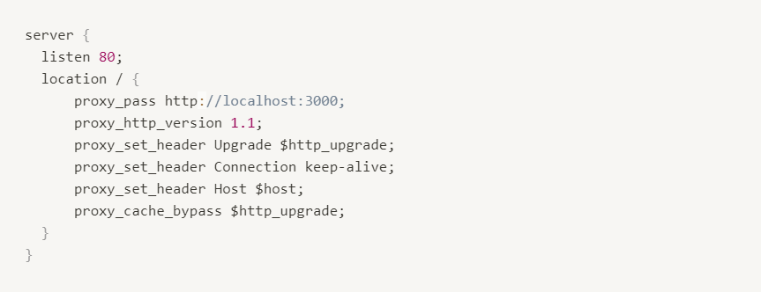

Press Esc, then type :wq! and press Enter to save and exit the file.

**DISCONNECT FROM THE VM**

exit

**CREATING APP SERVICE**

az login

az webapp up \

--resource-group resource-group-west \

--name hello-world1234 \

--sku F1 \

--verbose

**IF THE APP IS UPDATED**

az webapp up \

--name hello-world1234 \

--verbose

**DELETE AN APP SERVICE**

az webapp delete \

--name hello-world1234 \

--resource-group resource-group-west

**DELETE AN APP SERVICE PLAN**

az appservice plan delete \

--name [App Service Plan Name] \

--resource-group resource-group-west

**Create SQL Server**

az sql server create \

--admin-user udacityadmin \

--admin-password p@ssword1234 \

--name hello-world-server \

--resource-group resource-group-west \

--location westus2 \

--enable-public-network true \

--verbose

### Create Firewall rule

az sql server firewall-rule create \

-g resource-group-west \

-s hello-world-server \

-n azureaccess \

--start-ip-address 0.0.0.0 \

--end-ip-address 0.0.0.0 \

--verbose

### Create clientIp firewall rule

az sql server firewall-rule create \

-g resource-group-west \

-s hello-world-server \

-n clientip \

--start-ip-address <PUBLIC-IP-ADDRESS> \

--end-ip-address <PUBLIC_IP_ADDRESS> \

--verbose

### Create SQL Database

az sql db create \

--name hello-world-db \

--resource-group resource-group-west \

--server hello-world-server \

--tier Basic \

--verbose

### Delete DB

az sql db delete \

--name hello-world-db \

--resource-group resource-group-west \

--server hello-world-server \

--verbose

### Delete SQL Server

az sql server delete \

--name hello-world-server \

--resource-group resource-group-west \

--verbose

### Create a Storage Account

az storage account create \

--name helloworld12345 \

--resource-group resource-group-west \

--location westus2

### Create a Container

az storage container create \

--account-name helloworld12345 \

--name images \

--auth-mode login \

--public-access container